
San Fernando Valley Japanese American Citizens League Newsletter

April, 2008

Tak Yamamoto’s Testimonial Dinner

On March 1st, a number of our chapter members attended a testimonial dinner held for Tak Yamamoto at Cherrystone Restaurant in Gardena. Tak had mentioned at a recent board meeting that Sue Embry, in her will, requested such an event be held to honor Tak for his devotion to the success of the annual Manzanar Pilgrimage. Many in attendance, including newly elected Assemblyman Warren Furutani and Rose Ochi, described Tak's dedication extending over 30 years. In addition, during this time, he served with distinction as president of our chapter on two separate occasions. Congratulations Tak. We are all proud of you for what you have accomplished for our chapter and for our community.

Rose Ochi,
Tak Yamamoto
and
Mas Okui.

Article submitted by Phil Shigekuni

UPCOMING
EVENTS

COME JOIN US IN THE FUN AND ACTIVITIES

April 16 - Everything You Ever Wanted to Know About Gardening

April 26 - Manzanar Pilgrimage

May 3 - PSW Golf Tournament

May 21 - Nikkei Village Tea

June 1 - Scholarship Tea at Nikkei Village

July 5 & 6 - Obon Festival



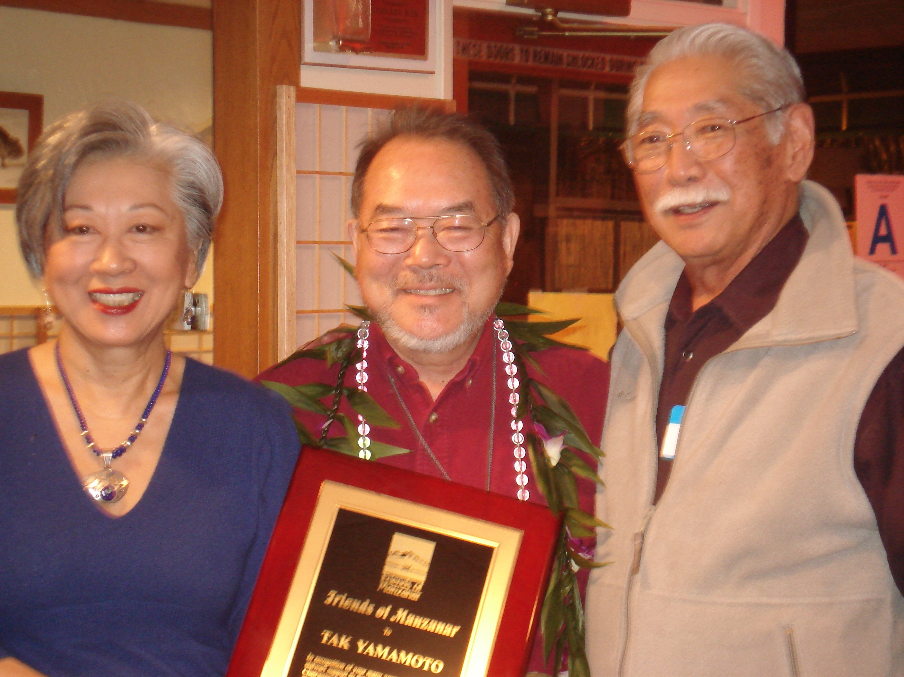

FAMILY CULTURAL FUN DAY

Circle Sunday, September 7, 2008
on your calendar for our Family Cultural
Fun Day. Actress Momo Yashima will read
her father, Taro Yashima’s books, “Crow Boy”
and “Umbrella”, to youngsters and oldsters.
Details in the June newsletter.

Please email
kyosh1@lausd.net
or send comments to:
Nancy Gohata
14229 Carl Street
Arleta, CA 91331
Questions or Comments?

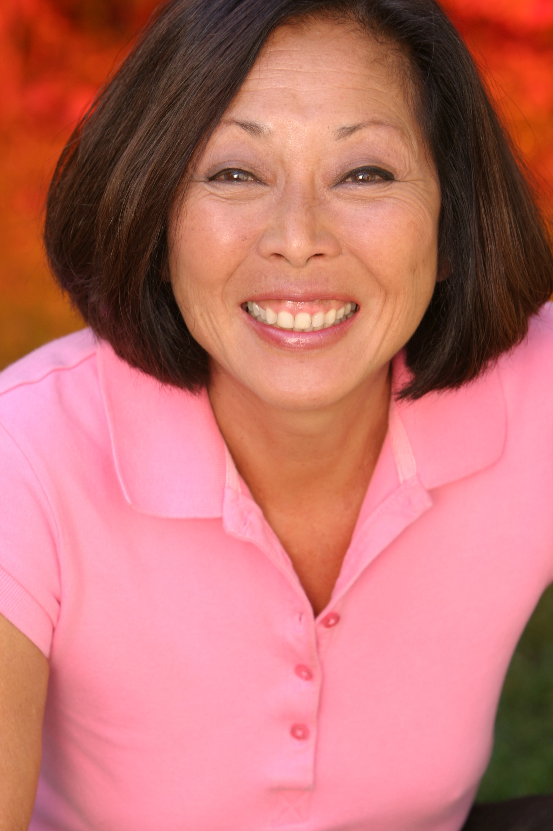



THE FOLLOWING ARTICLE APPEARED IN OUR APRIL 2007 NEWSLETTER.

HELP WANTED
Workers are needed for the JACL Doughball booth at the San Fernando Valley Hongwangi Buddhist Temple Obon Carnival on June 30 & July 1, 2007.
We are asking all JACL members to help us recruit people to work in the JACL Doughball booth at this year’s Obon Carnival. With so many of us participating in dancing, having commitments to other organizations, and an aging Board, we are finding it increasingly difficult to find help.
Please call Chieko Merz at (818) 773-8232, if you can lend a hand. Your help would be greatly appreciated!
OUR JACL NEWSLETTER IS SENT TO OVER 200 MEMBERS, YET CHIEKO DID NOT RECEIVE ONE PHONE CALL TO HELP WITH OUR BOOTH LAST YEAR. THIS YEAR, WE ARE AGAIN ASKING FOR YOUR HELP. THE PC HOLIDAY AD CAMPAIGN AND THE DOUGHBALL BOOTH ARE OUR ONLY MEANS OF RAISING FUNDS FOR OUR CHAPTER. WE REALLY NEED YOUR HELP. IF YOU CANNOT HELP PERSONALLY, PLEASE HELP US RECRUIT. MAYBE YOUR CHILDREN, GRANDCHILDREN, NIECES, OR NEPHEWS WOULD BE WILLING TO PARTICIPATE. THIS YEAR THE OBON CARNIVAL IS ON JULY 5 & 6, 2008.

PLEASE CALL CHIEKO, (818) 773-8232 – YOUR HELP IS DESPERATELY NEEDED AND WOULD BE GREATLY APPRECIATED!

EVERYTHING ABOUT GARDENING

ROY IMAZU, SFV Gardening Specialist, will address everything you ever wanted to know about GARDENING. Free lunch and seedlings.
(For details, see original article printed in the February issue.)

Date: Wednesday, April 16, 2008
Time: 10:00 a.m.
Place: Home of Chieko Merz (Tel; 818-773-8232)
10120 Oso Avenue, Chatsworth, CA 91311

RSVP by: April 5th
Yas Gohata 818-899-4237 Chieko Merz 818-773-8232 Mitzi Kushida 818-360-6718






LAKE BALBOA CHERRY BLOSSOM PICNIC
Saturday, March 15, 2008

Sakura, sakura.....I felt as though I was in Japan viewing the cherry blossoms, not at Lake Balboa in Van Nuys. After getting lost in the park (only I could do that) and being rescued by Clara Hashimoto, the beautiful scenery took my breath away. Luckily the weather cooperated, as it did not rain as predicted, and the sun was shining.
About 20 members and friends, walked around the lake, some leisurely and others at a brisk pace. Barbara Nakatsu took pictures while others enjoyed socializing. By 10:00 a.m., Marion Shigekuni started the exercise program with stretching and warming up exercises. Next Clara led the non-stop aerobic movements (I was wondering when we would be taking a break). Phil Shigekuni closed the program with some Tai' Chi and meditation. I was very impressed with the entire routine and everyone enjoyed themselves and worked up an appetite.
It's been a long time since I've been to a Japanese potluck. The food was impressive and delicious and included chashu, several chicken dishes, rice dishes, potato salads, Chinese chicken and somen salads, just to name a few. I think we all went up for seconds and some for thirds.
By noon, the clouds moved in and it got very cold. Everyone enjoyed the hot tea while talking about the good food, beautiful morning, and not having to cook dinner because there was enough food to take home. How perfect is that? I had a
wonderful, new experience and enjoyed
the company, and I'm sure, everyone
else did also.

Cherry trees at Lake Balboa.
Clara Hashimoto and Marion Shigekuni
lead JACLer in moderate exercise.
Article submitted by Linda Tanaka

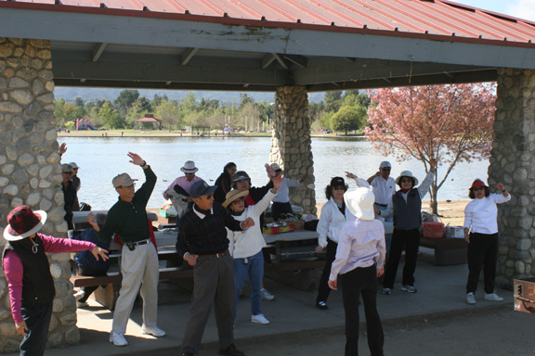

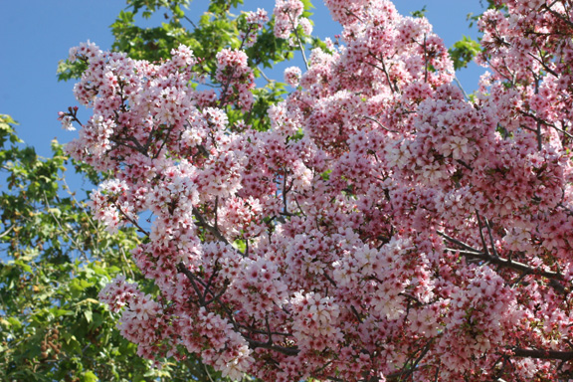

Revelations & Resilience: Exploring the Realities of Hapa-ness

On April 12, 2008 from 2:00 – 4:00 p.m., there will be a panel discussion on "hapa identity” at the Japanese American National Museum. The following links provide more detailed information:
Discover Nikkei posting:
http://www.discovernikkei.org/forum/en/node/2299
janm.org events calendar:
http://www.janm.org/events/2008/04/#12



ROAR OF THE TIGER – THE IVA TOGURI STORY

On Friday, March 22, 2008, fifteen JACLers and their friends attended “Roar of the Tiger”, a play about Iva Toguri, identified as “Tokyo Rose” during World War II. A cast of six, headed by Momo Yashima as Iva Toguri, played multiple roles to tell the story of an American citizen whose broadcasts from Japan were aimed at American troops during World War II. Convicted of treason, Toguri was pardoned in 1977. This powerful play poignantly reveals the tragic events surrounding Iva Toguri’s life, which many of us were unaware of before seeing this play.
In attendance that evening was the writer Glenn Conner Johnson. He was introduced to Dr. Sanbo Sakaguchi, who was a college classmate of Toguri at UCLA between 1935-1939. Johnson was interested in talking to Dr. Sakaguchi about that period in Toguri’s life.
Rather than drive, twelve of us rode the subway from the Metro station in North Hollywood. Then we walked two blocks to Miceli’s, the oldest Italian restaurant in Hollywood, for a tasty meal before the play. After the play, we stopped for dessert at Beard Papa’s before the ride home. Considering LA’s high gas prices and traffic issues, the round-trip senior fare of $1.10 was a real bargain.
Go to http://en.wikipedia.org/wiki/Iva_Toguri_D’Aguino for the biography of Iva Toguri.

SFVJACL WEBSITE

Program Co-Chair Karl Nobuyuki has designed a website for our Chapter. Go to www.sfvjacc.com/JACL.htm to view the names of our 2008 Board members, 2008 schedule of activities, and a photo gallery of our events.



SELANOCO INSTALLATION

Sachie Doi, Doreen Kawamoto, Nancy and Yas Gohata attended the SELANOCO Installation Luncheon on Sunday, January 26, 2008 at the Amada Club in Buena Park. Led by President Steven Matsubara, the SELANOCO Chapter boasts a 34-member Board of Directors. The keynote speaker was Dean Togi, Ph.D. Assistant Professor of Asian American Studies at CSU Long Beach. Using graphs, Dr. Togi, presented the status of Japanese in the United States in regards to immigration, interracial marriages, and the hapa community. One striking statistic showed that there are more Shin Nisei (Japanese who immigrated after WWII) in the United States than those who came in the first wave of immigration. So today, there are more Japanese Americans who do not share the internment history of our isseis, niseis, sanseis, and yonseis. Dr. Togi posed this situation as “food for thought” in identifying the Japanese American community.



Please help us lower our postage cost?

You can greatly help our chapter by getting the Chapter newsletter via email.
Please go to kyosh1@lausd.net and register your e-mail address.

SFV-JACL / SFV-JACC Scholarship Program 2008
Mark your calendars! Sunday June 1, 2008, 2PM, Nikkei Village Dining Hall

By: Jean-Paul deGuzman, Scholarship Committee Co-Chair, jpd73619@ucla.edu

It’s a bumper crop this year! All are invited to join the SFV-JACL/SFV-JACC Scholarship Committee as we recognize the outstanding academic and extracurricular achievements of the following talented students:

Stephanie Mieko Cohen Eric N. Inamine
Viewpoint School Hart High School

Irene N. Mizuki Robert M. Morita
Cleveland High School Kennedy High School

Courtney Nicole-Kanani Mun Clay E. Thibodeaux
Chaminade College Preparatory Taft High School

Our awardees have lent their times and talents to a variety of organizations ranging from the Special Olympics, the Boy Scouts of America, Hula Halau O’Kamuela, and of course, the JACC. We have AP Scholars, National Merit Scholars, actresses, environmentalists, debaters, swimmers and even a principal oboist!
We are also honored to have as our keynote speaker, Lane Ryo Hirabayashi. A UC Berkeley-trained anthropologist, Dr. Hirabayashi is the inaugural George and Sakaye Aratani Professor of the Japanese American Internment, Redress, and Community and the current chair of the Department of Asian American Studies at UCLA. Prior to coming to Los Angeles, Dr. Hirabayashi held positions at San Francisco State University, the University of Colorado and UC Riverside. A prolific scholar in Asian American and Ethnic Studies he is the author of three books, editor/co-editor of five books, and has written over thirty articles.
Since 1973 the JACL and JACC have collaborated in awarding the rising stars of the community. Please join us for the 35th joint Scholarship Program and spread the word about our scholarships for 2009!
This year’s selection committee included: Clara Hashimoto, Kay Inaba, Doreen Kawamoto, Barbara Okita, Geri Shiraki, Linda Tanaka, Sumi Yamaguchi, and Jean-Paul deGuzman.

Save the Date!
• Sunday June 1, 2008, 2PM, Nikkei Village Dining Hall •



VOICES FROM OKINAWA

On Sunday, March 2nd, 24 JACLers attended the East West Players production of “Voices From Okinawa”. Written by 80-year-old author and playwright, Jon Shirota, “Voices of Okinawa” tells the story of Kama Hutchins (played by Joseph Kim), an American of one-quarter Okinawan descent, who receives his own cultural education as he teaches English to local Okinawans struggling with their relationship to American military GIs stationed there. Amy Hill, who portrayed Obaa-san, Kama’s grandaunt, gave an outstanding performance using her comedic skills to entertain. Obaa-san’s character embodies Okinawa’s ancient traditions. The eight-member cast, half who hailed from Japan, all gave strong performances.
Before the play, we had met in Chinatown at “Oceans Seafood” for dim sum. It was the first time for most of us at this restaurant, and personally, I prefer “Empress Pavilion”. However, we all seemed to enjoy our lunch, but Al Kushida and Phil Shigekuni wished they had sat at Tak Yamamoto and Yas Gohata’s table.





THIRD TUESDAY MOVIE OUTINGS

In February, seven movie goers went to see “The Band’s Visit”, a movie about a small, Egyptian police band that arrives in an Israeli desert town and experiences cross-cultural relations to address serious topics. Chieko Merz writes: “Warm, charming, touching, funny, gentle and kind. What more could you want from a film?”
“Caramel” was the choice for two of us. A Lebanese film about five women, each with a problem. Chieko offered the following: “Universal trials and tribulations of women. No matter the country or culture, all women have common bonds and shared experiences. Definitely a “chick flick”. Not for any man who is NOT in touch with his feminine side”.
In March, six of us went to see In Bruges . Barbara Okita gives us this synopsis. In Bruges is about hit men Ray (Colin Farrell) and Ken (Brendan Gleeson), who after a hit gone wrong, are sent to stay in Bruges, the most beautiful medieval city in Belgium, by their psycho boss Harry (twice nominated academy award nominee Ralph Fiennes). Harry sends them there because he wants Ray to be in a beautiful place before he has Ken kill him.
In Bruges is a movie of extreme contrasts; a very dark comedy with extremely funny dialogue. Reactions of our movie-going group were extreme contrasts, too. Some comments included, “I was laughing so hard I missed some of the following dialogue”, not my cup of tea”, “kind of gory”, “really enjoyed it”, “the funny dialogue is a great mix with the dark theme.”
Disclaimer: If you’re offended by the “f…” word, this is not the movie for you. It didn’t get an “R” rating for nothing.

NIKKEI VILLAGE AFTERNOON TEA

Please join us for JACL’s second annual Nikkei Village Afternoon Tea. Come enjoy an afternoon of delicious food, warm conversation and wonderful entertainment.
Date: Wednesday, May 21, 2008
Time: 3:00 p.m.
Place: Nikkei Village, 9551 Laurel Canyon Blvd, Pacoima

Please RSVP by Friday, May 16th to Linda Tanaka at lkitai@hotmail.com or (805) 527-1224



2008 MINORU YASUI ORATORICAL COMPETITION

The Minoru Yasui Oratorical Competition is named in memory of Minoru Yasui, an attorney and civil rights activist, who challenged the constitutionality of the curfew order that were imposed against Japanese Americans before their internment.
The competition is open to high school students, age 16 or older, ro full-time undergraduate college students. Competitors must be members of JACL at the time of the District Council and National Competitions.
For more information about the competition contact JACL Midwest Director Bill Yoshino at JACLMRO@aol.com



Project: Community!
JACL & Rising Stars Youth Leadership Program

PROGRAM OUTLINE
The purpose of Project: Community! is to develop and empower the youth's voice in Little Tokyo. Through a series of interactive sessions, high school participants will gain an understanding of identity as well as the importance of preservation of the Japanese American community. Each session will gather facilitators and speakers from various parts of the community to conduct interactive workshops focused on specific topics ranging from identity, to the power of place, to grassroots organizing on a youth level.
- Who? High School Students (9th-12th Grades)
- When? Every Tuesday evening from June 24, 2008-August 12, 2008 (6/24, 7/1, 7/8, 7/15, 7/22, 7/29, 8/5, 8/12), 6:00-9:30pm
- Where? Sessions will take place in the Japanese American Cultural and Community Center (JACCC)
* SESSIONS
Session 1: Identity & Community (Parents must be in attendance)
- Understanding the idea of what a community is
- Understanding your own individual identity with the JA community
- Your own personal definition of the JA Community
- Discussion on JA Community
Session 2: The Power of Place
- The significance of a physical community to an ethnic population
- Linkage of Little Tokyo and the JA Community
Session 3: Little Tokyo in Danger
- Explanation of issues the community faces
- Looking at the future of the community
Session 4: Community Organizations
- Explanation of the different non-profits in the community
- What non-profits do for the community
Session 5: How can you be a voice in the community?
- The power of the grassroots activism
Session 6: Parent's Night (Parents must be in attendance)
- Explanation of the program to the parents
Session 7: The Strategy
- Event planning 101
- Community event planning
Session 8: Program Culmination Event

APPLICATIONS ARE DUE/POSTMARKED BY FRIDAY, APRIL 11, 2008
(Original due date was April 1, 2008)

FOR MORE INFORMATION, please contact JACL at:
www.jaclpsw.org
programs@jaclpsw.org
(213) 626-4471



Health Notes from JACL Health Benefits Trust

It's the first warm, sunny day after a long winter. You step outside for a deep breath of fresh air, close your eyes and turn your face to the sun. It feels so good. The soothing warmth of the sun on your skin ... the healthy look of a suntan ... the deep wrinkles and age spots. That's right, wrinkles and age spots.
Despite the still-prevalent image of a tan being healthy, excessive exposure to the sun is responsible for much of the skin damage associated with aging. It's a lifelong process, as over time your skin slowly accumulates the damaging effects of the sun. Much of the damage is merely cosmetic, but some can be deadly. Excessive sun exposure is the leading cause of skin cancer, by far the most common form of cancer diagnosed today. Almost half of all Americans who reach age 65 will develop at least one skin cancer.
But there are precautions you can take. Armed with adequate sunscreen and protective clothing, you can - at any age - prevent damage to your skin. In addition, with proper care, topical skin medications and new surgical techniques, you may be able to lessen or even reverse some skin damage.
With age your skin normally becomes thinner and finely wrinkled. Oil-producing (sebaceous) glands become less active, and your skin becomes drier. The number of blood vessels in your skin decreases, and your dermis can get thinner and more fragile, so you lose your youthful color and glow. In addition, with aging your skin replaces old cells more slowly and cells repair themselves less effectively. This can result in slower turnover of surface skin and slower healing of skin damage.
It's difficult to resist the appeal of a suntan. But remember, there's a dark side to your tan. Every minute you spend unprotected in the sun damages your skin and increases your risk of skin cancer.

For the full text of this article, please visit Blue Shield of California’s web site at www.mylifepath.com.

THANKS FOR YOUR GENEROSITY

Thanks to the following people for their generous donations.

Harriet & John Nishizaka in celebration of the birth of their second granddaughter, Maya Michiko, on December 31, 2007.

Junko Wayama to the JACL Scholarship Fund.

Dr. Mary and James Oda for the holidays.

Adeline Shoji as a thank you to the Chapter.

Tom & Michi Imai, Sam & Terry Uyehara, and Paul & Nobuko Jonokuchi for door prizes for the Chapter Installation.

Caroline Sanwo of Heritage Source - A percentage of the sale of books at the Family Fun Day event in 2007.

Shig Yabu, Ventura Chapter member - A percentage of the sale of his book “Hello Maggie”.

39TH ANNUAL MANZANAR PILGRIMAGE
April 26, 2008

The 39th Annual Manzanar Pilgrimage is scheduled for April 26, 2008, at the Manzanar National Historic Site, beginning at noon. The popular MAD (Manzanar At Dusk) program begins at 5:00 pm.

MAD (Manzanar At Dusk)
The evening program will begin at 5:00 pm. Share stories, experiences, inter-generational discussions, poetry, open mike, etc.
The venue will be announced at the pilgrimage.

Bus from Los Angeles
For those interested in taking the bus from Los Angeles, two buses sponsored by The Manzanar Committee will be leaving Little Tokyo sharply at 7:00 am, Saturday, April 26. One bus will be leaving the Pilgrimage site at 4:00 pm. Returning to L.A. at 7:00 pm. The second bus will be leaving after the “MAD” session, returning to L.A. around 11:00 pm. The cost per person is $50. For reservations and additional information, please call (323) 662-5102. Availability is based on a first come, first served basis. Confirmations and trip details will be mailed.

Driving fro the Los Angeles Area
The distance from Los Angeles to Manzanar is approximately 230 miles one way and will take about 4 1/2 hours including stops. Take Interstate 5 (Golden State Freeway) north. Then take California Highway 14 (Antelope Valley Freeway) north. Highway 14 turns into US 395 near Ridgecrest. Continue on US 395 past Lone Pine. Manzanar is approximately 8 miles after Lone Pine. If you reach Independence, you’ve gone too far. The Pilgrimage is held at the northwest corner of the site near the cemetery monument. Enter the site at the historic sentry posts and follow the tour road to the cemetery.

For more information: (323) 662-5102, manzcomm@yahoo.com, www.manzanarcommittee.org

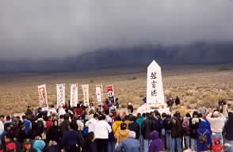
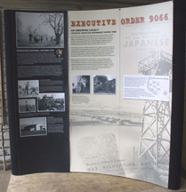



Sumi’s Cheer Corner

Congratulations to Mitzi & Al Kushida who celebrated their 50th anniversary on March 29, 2008.
Flowers were sent to Adeline Shoji as she continues her battle with cancer.

Thanks to the following professionals/businesses who supported our Pacific Citizen Holiday Issue fundraiser.

JAMES “JIM” HIGASHIDA CONCETTA YAMAUCHI
Prudential - California Realty SFV Realty .
9003 Reseda Blvd., Suite 105 Professionals, Inc. .
Northridge, CA 91324 13530 Glenoaks Blvd.
(818) 993-8900 Ext 318 Sylmar, CA 91342
(818) 970-1965

CHARLES SHODA & ASSOCIATES JAMI TANIHANA
Merit Realty M.A. in Audiology, CCC-A
7810 Lankershim Blvd. Sonus Hearing Care Professionals
North Hollywood, CA 91605 19525 Nordhoff St., Ste 5
(818) 765-1501 Northridge, CA
(818) 734-9124
SEKI, NISHIMURA & WATASE
KENNETH D. WATASE BIRD/MARELLA
Attorney at Law PAUL S. CHAN, ATTORNEY
1055 Wilshire Blvd. Suite 1900 1875 Century Park East, 23rd Floor
Los Angeles, CA 90017 Los Angeles, CA 90067-2561
(213) 481-2869 (310) 201-2100
kwatase@snw.law.com psc@birdmarella.com
www.BirdMarella.com

RICHARD YAMAUCHI FUKUI MORTUARY
Certified Public Accountant 707 E. Temple Street
Personal Financial Specialist Los Angeles, Ca 90012
13429 Pala Avenue (213) 626-0441
Rancho Cascades, CA 91342
(818) 364-1500

PAUL ARNESON – CONSULTANT David G. Masevedjian, Attorney at Law
PROMENADE TRAVEL 3360 Barham Blvd.
31011-B Agoura Road Los Angeles, CA 90068
Westlake Village, CA 91361-4637 (323) 876-5050
(818) 993-1896

LAW OFFICES OF LAURIE SHIGEKUNI TRANSTECH
2555 Ocean Avenue, Suite 202 Hal Suetsugu, Vice President
San Francisco, CA 94132 624 Brea Canyon Rd.
(800) 417-5250 Walnut, CA 91789
laurie@calestateplanning.com (909) 595-8599





Japanese American Citizens League
Membership Application
Membership Catagories
Regular/Individual:
Regular sustaining members of the organization.
Couple/Family:
Membership for an individual, their spouse/partner and any children under 25 years of age.
Youth/Student:
Members 25 years of age or younger or students currently enrolled in a college, trade school, or university.
1000 Club:
A membership category where members make a larger annual contribution to their chapter and national programs of the organization.
1000 Club Life:
Members who pay a lump sum to establish a lifetime membership.
1000 Club or Century Club Spouse:
Spouse or partner of a JACL 1000 Club or Century Club member.
Century Club:
An exclusive membership category where members make a larger annual contribution to their chapter and national programs of the organization.
Century Club Life:
An exclusive membership category where members pay a lump sum to establish a lifetime membership.
Millennium Club:
A premier membership category where members make a larger annual contribution to their chapter and national programs of the organization.
Millennium Club Spouse:
Spouse or partner of a JACL Millennium Club member.

New Member Renewing Membership Gift Membership San Fernando Valley Chapter

Regular/Individual $67.00 1000 Club Individual $100.00 Century Club Spouse $32.00
Couple/Family $110.00 1000 Club Spouse $32.00 Century Club Life $5000.00
Youth/Students $25.00 1000 Club Life $3000.00 Millennium Club $1000.00
Century Club $175.00 Millennium Spouse $36.00

Member Information
Member ID: ___________________________(renewals only)

First Name ________________________________________________________
Last Name _________________________________________________________

Street Address _________________________________________________________
Suite/Apt. # _________________________________________________________
City _________________________________________________________
State ____________________________ Zip Code ____________________
Phone _____________________ (Work/Day) _____________________ (Home)

Payment Method
Check Credit Card
Please make checks payable to: Visa MasterCard American Express
Japanese American Citizens League Card Number _____________________________
Expiration Date __________________(month and year)
Send the completed application along with your payment via U.S. mail to:
JACL Membership
P.O. Box 45397
San Francisco, CA 94145-0397

LAW OFFICES OF LAURIE SHIGEKUNI TRANSTECH
2555 Ocean Avenue, Suite 202 Hal Suetsugu, Vice President
San Francisco, CA 94132 624 Brea Canyon Rd.
(800) 417-5250 Walnut, CA 91789
laurie@calestateplanning.com (909) 595-8599

