CC SPRING CLEAN-UP
By: Lois Okui

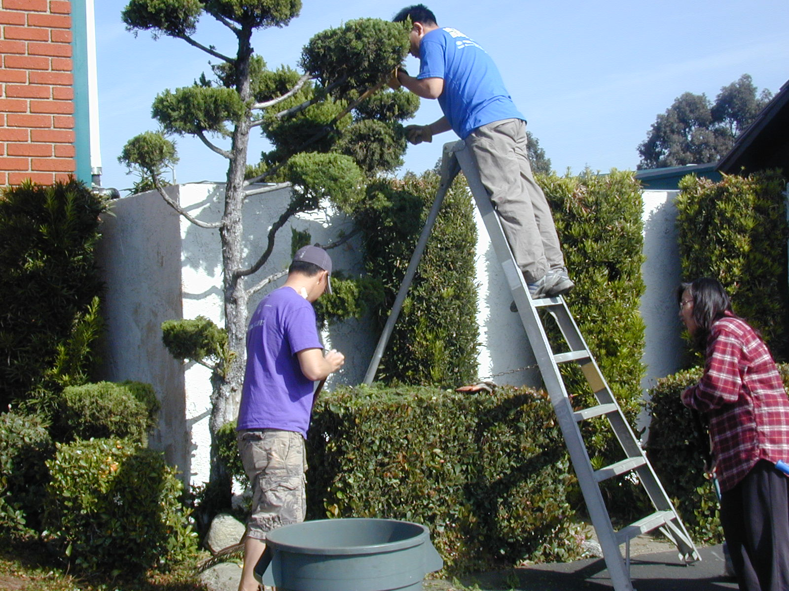Thank you to all the people that came and worked so hard at our CC Clean-up. We had over a 100 people helping, many from the Athletics and the Bert Corona Middle School. It was wonderful to see everyone, especially the kids, working together to achieve the same goal—to beautify our Center.
Athletics did a very thorough cleaning of the gym. They did everything…from removing the cobwebs from the ceiling to power scrubbing the floors and walls in the bathrooms. They also provided the manpower and muscle to take desks, furniture and even an extremely heavy offset press machine to the trash bin.
The Bert Corona Middle School did the clean up in the Pioneer Building. They mopped all the floors, scrubbed all the tables and dusted everything.
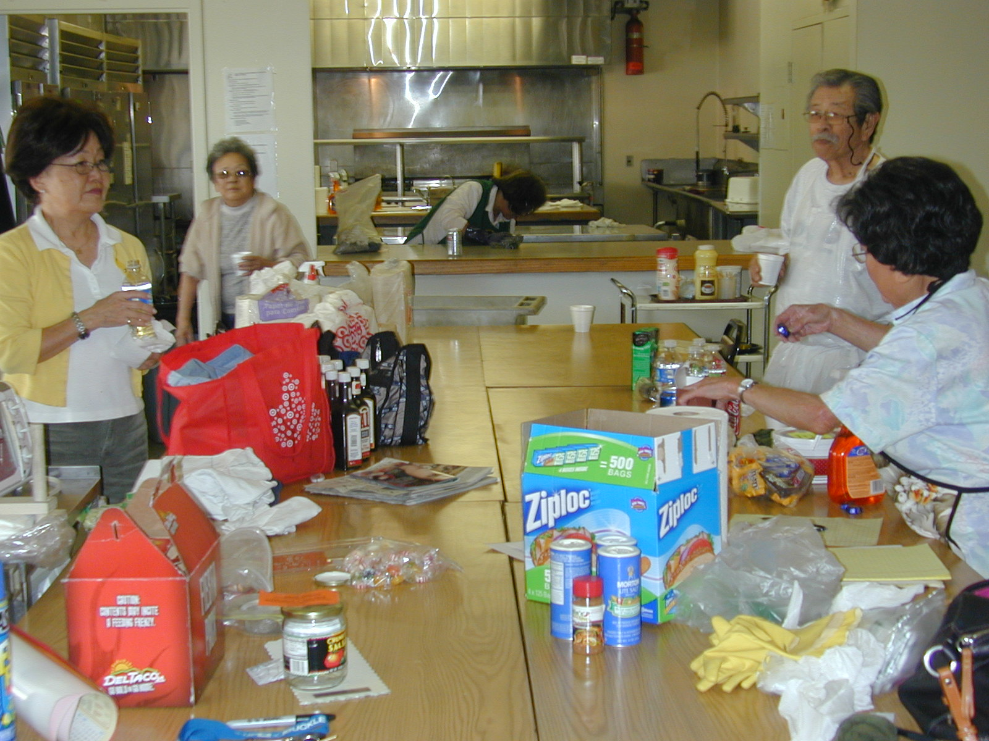The crew from the Hot Meal Program took care of cleaning the kitchen and their storage room. Japanese School had their students help out, too, even though it was during school hours. And of course, we need to thank those that worked on the grounds.
Every time I look around the Center, it reminds me of all the people who came out to help and it warms my heart. I know that the pioneers of the CC that long have past would be pleased. 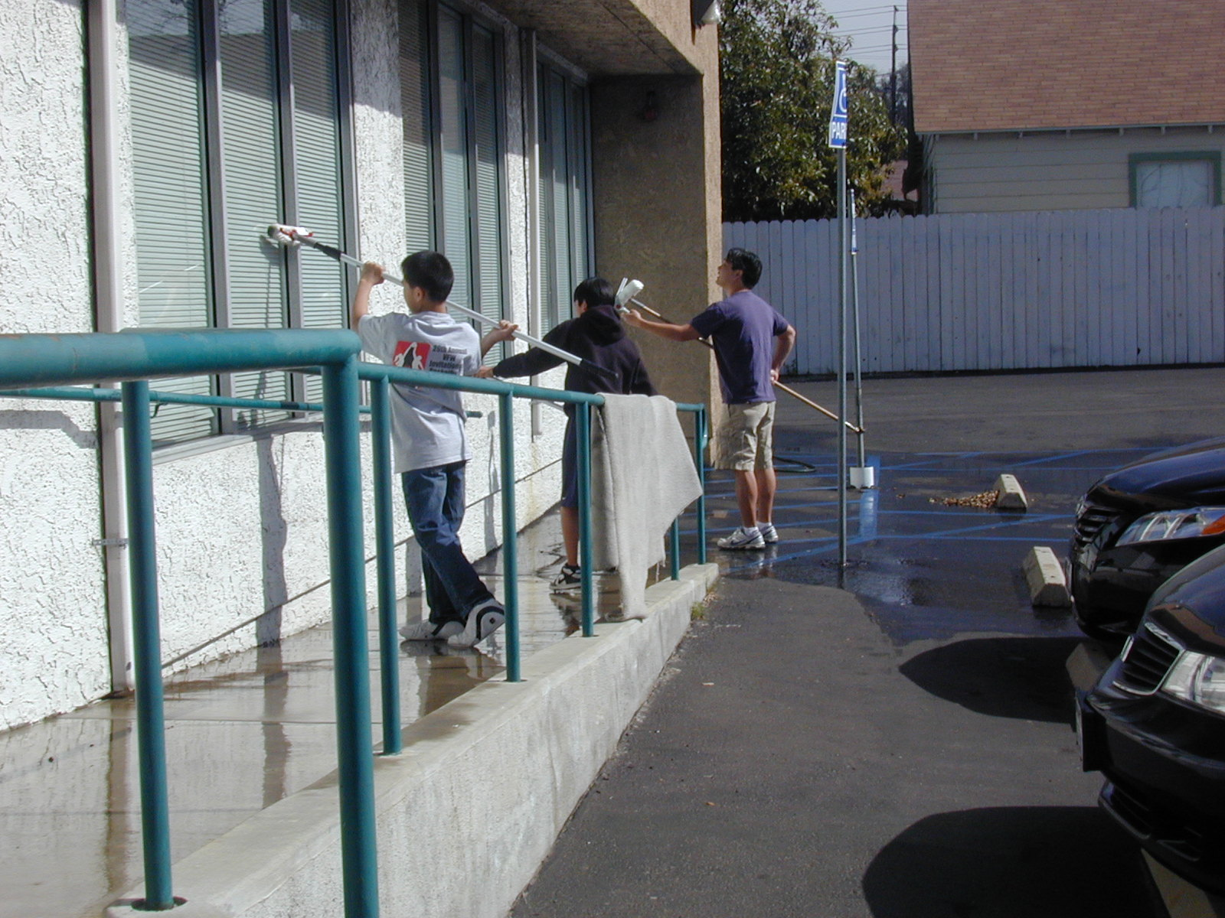

A special thanks to:
Rick Shindo and Craig Tanaka for cleaning all the cobwebs from the ceiling and walls of the gym. Gary Yoshino for all the electrical work he did in the gym bathrooms and Pioneer Building. And of course, to Roy Imazu, for coordinating the clean-up.

#30

