Erin Yokomizo
SFVJACC Nisei Queen Candidate

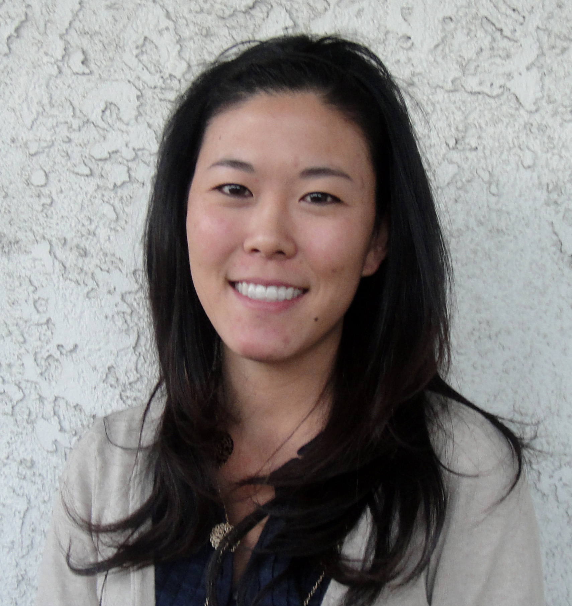Hello! My name is Erin Yokomizo, and I'm pleased to represent the San Fernando Valley Japanese American Community Center Coordinating Council this year at Nisei Week. I am 23-years old and recently graduated from USC with a major in Communication and a minor in Art History. I am currently combining the two studies in a career working in the Communications and Marketing department at the Los Angeles County Museum of Art.
Though I never played CC basketball, I have experienced ties to the center through my church just down the street, the San Fernando Valley Holiness Church (SFVHC). SFVHC has utilized the Community Center’s facility to host a number of its annual events, and I have always appreciated the center as a warm place of hospitality and a strong feeling of community.
One of the things I enjoy most is serving on youth staff for our church’s high school students. The ability to see personal growth and maturity in students throughout the years is an invaluably rewarding experience. In my free time, I love to travel—I studied abroad in Europe last year, and to experience the history there, especially the art history, was truly an amazing thing for me. I enjoy snowboarding and discovering new places to eat in the Los Angeles area. My most recent food adventure was to a shaved ice shop in Northridge. I also enjoy sports and love cheering on the Lakers in their quest for yet another ring.
This year for Nisei Week, my platform will be Zoe International, which is a non-profit organization that effectively works to fight against child slavery and human trafficking. I hope you will join me in supporting this cause. Again, I appreciate the opportunity to represent our San Fernando Valley community, while developing a deeper personal appreciation for our Japanese-American heritage.

