The Roar of the Tiger New Year
By NJ Nakamura

Grrr……roared the 2010 Year of the Tiger. Yes, the San Fernando Valley Japanese Language Institute’s celebration of the New Year was a roaring, fun-filled evening. Emcee Sheila Jennings, a Caucasian who lived briefly in Japan, loudly shouted “Itadaki mas” to signal the start of eating the bento dinner and then officially concluded the delicious meal by loudly shouting “Gochiso sama deshita.”

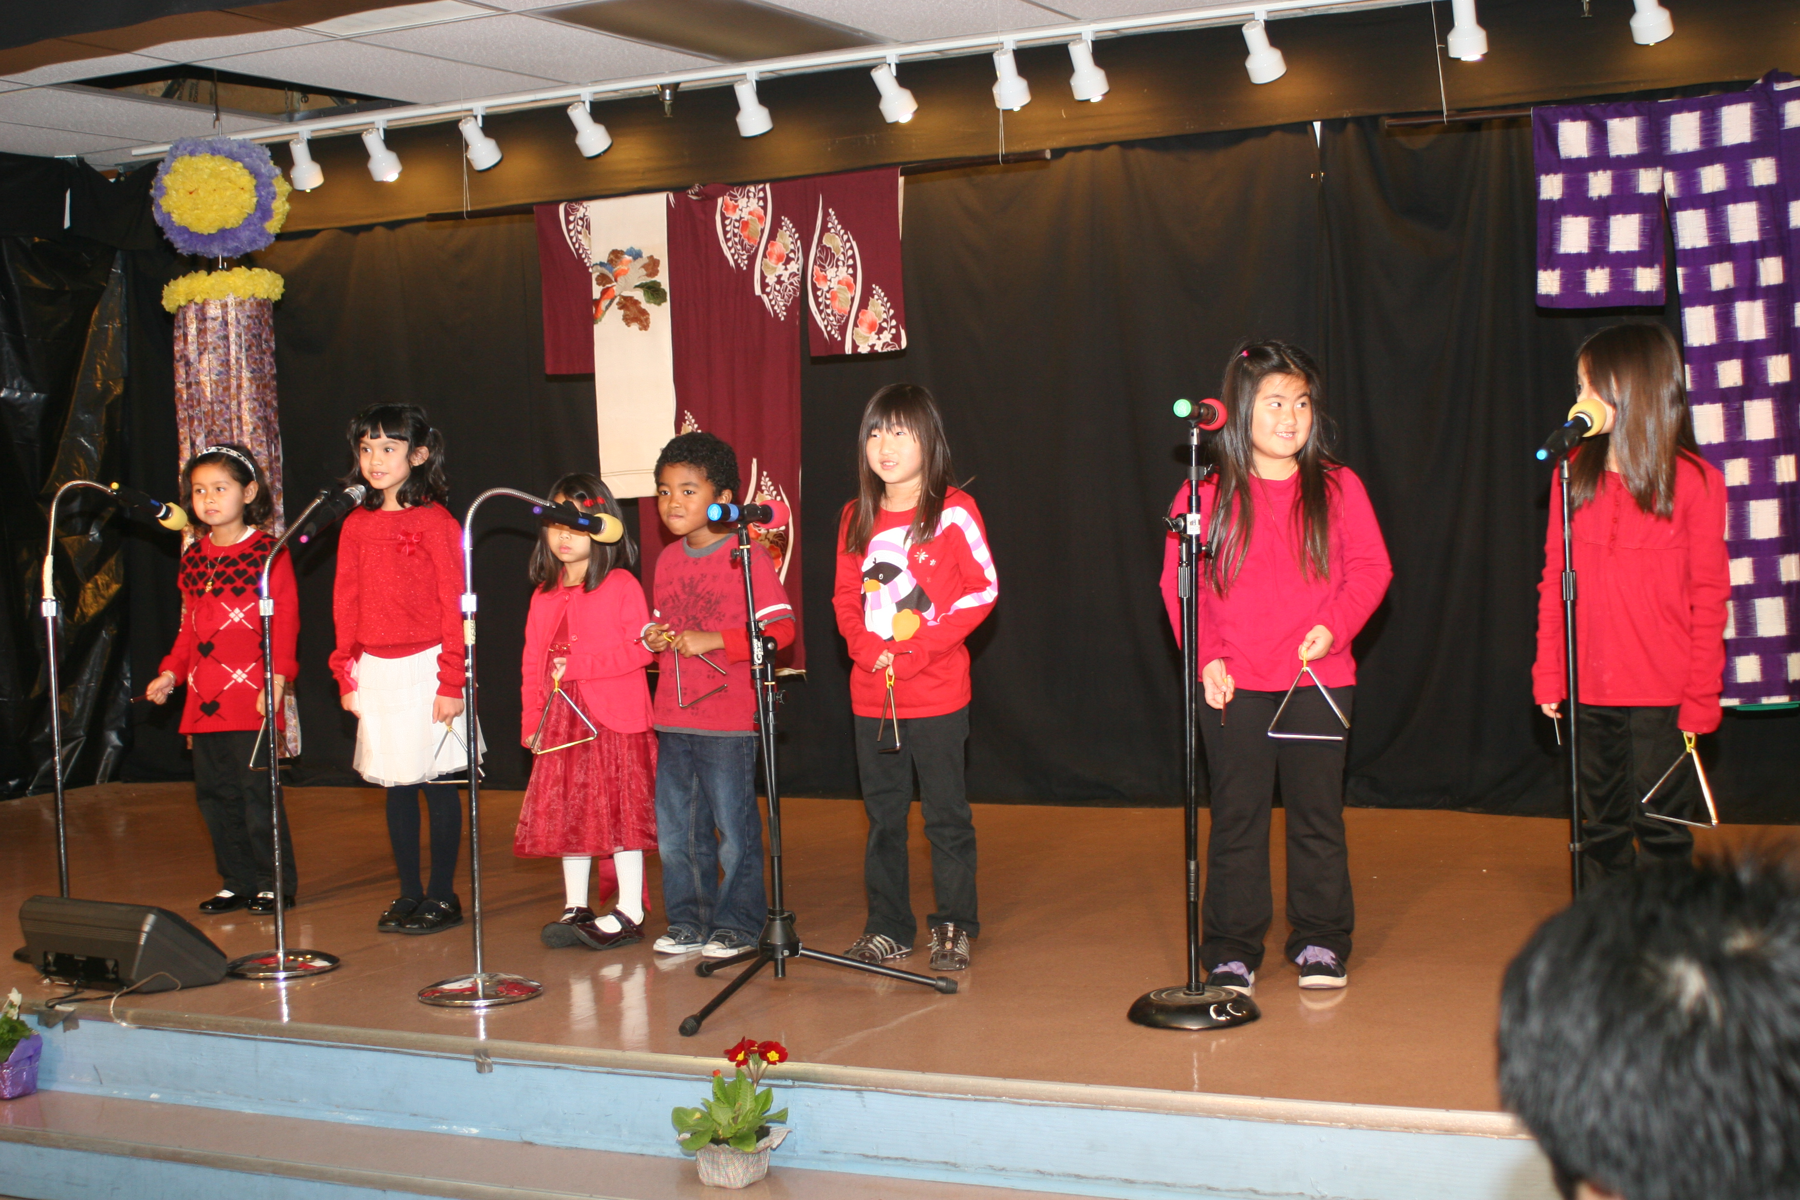
The entertainment began with cute, school age children using hand motions as they sang the Japanese words to “Ponyo.” Then several adults performed on the koto and ukulele. Added to that was the dynamic Enka singing about a samurai and then the teachers sang, “Shiawase Nara Te Wo Tatakou” (also known as “If You’re Happy and You know It Clap Your Hands”), which brought the guests to their feet with clapping hands.

Throughout the evening, everyone focused their close attention to the raffle ticket numbers that were announced by PTA President & clever comedian, Yoshiko Kawada. That’s because there were two, 10 feet tables piled high with beautifully wrapped raffle prizes, tempting all who walked passed the tables to buy more raffle tickets. Even bags of rice and bottles of shoyu were wrapped in clear cellophane and tied with pretty ribbons. I was extremely lucky, lucky and lucky because I won a large Harry & David container of mint chocolates, a pink bottle of Sayuri sake and a bottle of excellent Petite Sirah from the Barnwood Winery and the Santa Barbara Highlands Vineyard. Such fun then and in the near future!

To bring even more smiles to everyone, all the guests received a goodie bag filled with can coffee, seasoned nori, green tea bags, fresh pan, wasabi sembe, and many more treats.
Those generous donations and prizes were the results of tireless effort by the parents and teachers. They worked together to make the school’s celebration of the New Year a memorable success.

This Japanese school has been in existence for 86 years and classes have been held at its current location for 51 years. There are eight grade levels. Those students, who have completed Level Four, with at least 150 hours of study, qualify to take the Japanese Proficiency Examination. This test is offered worldwide and the certificate officially confirms that the student has mastered the basics of the Japanese language with at least 800 words and 100 Kanji. As students advance in their study of the Japanese language, they have the option of taking the proficiency examination for the next level. Yoshiko proudly introduced the students who received the proficiency certification.

According to Chinese astrology, the Tiger years have traditionally brought dramatic changes. Yet, with respect to all beliefs, it is hoped that 2010 brings continued good health and enjoyment in all things.
#30

